MACH4METAL

metalworking machinery
Transito 21, 6909 DA Babberich, Netherlands
Tel. + 31 (0)316 – 247123
Fax. + 31 (0)316 - 247956
info@mach4metal.com
www.mach4metal.com
Bank No : 66.52.13.883
IBAN : NL33 INGB 0665 2138 83
BIC : INGBNL2A
VAT : NL 815393635B01

PBR Legnano T 450 SNC CNC Lathe

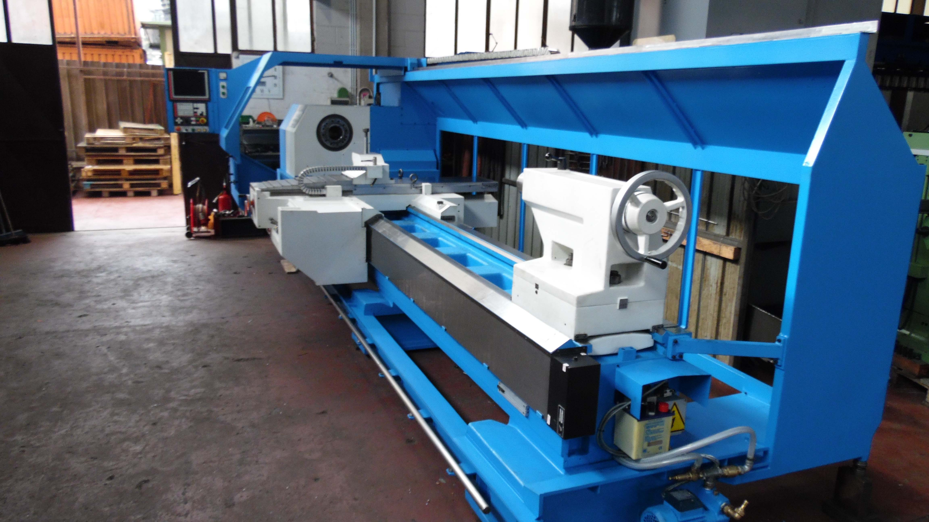
- Make : PBR Perico Baroni Raimondi
- Type : T 450 SNC
- Age : 1996 GO 2014
- No. : 425 94PB921

- Swing over bed : 920
- Swing over support : 550
- Centre height : 450
- Bed width : 570
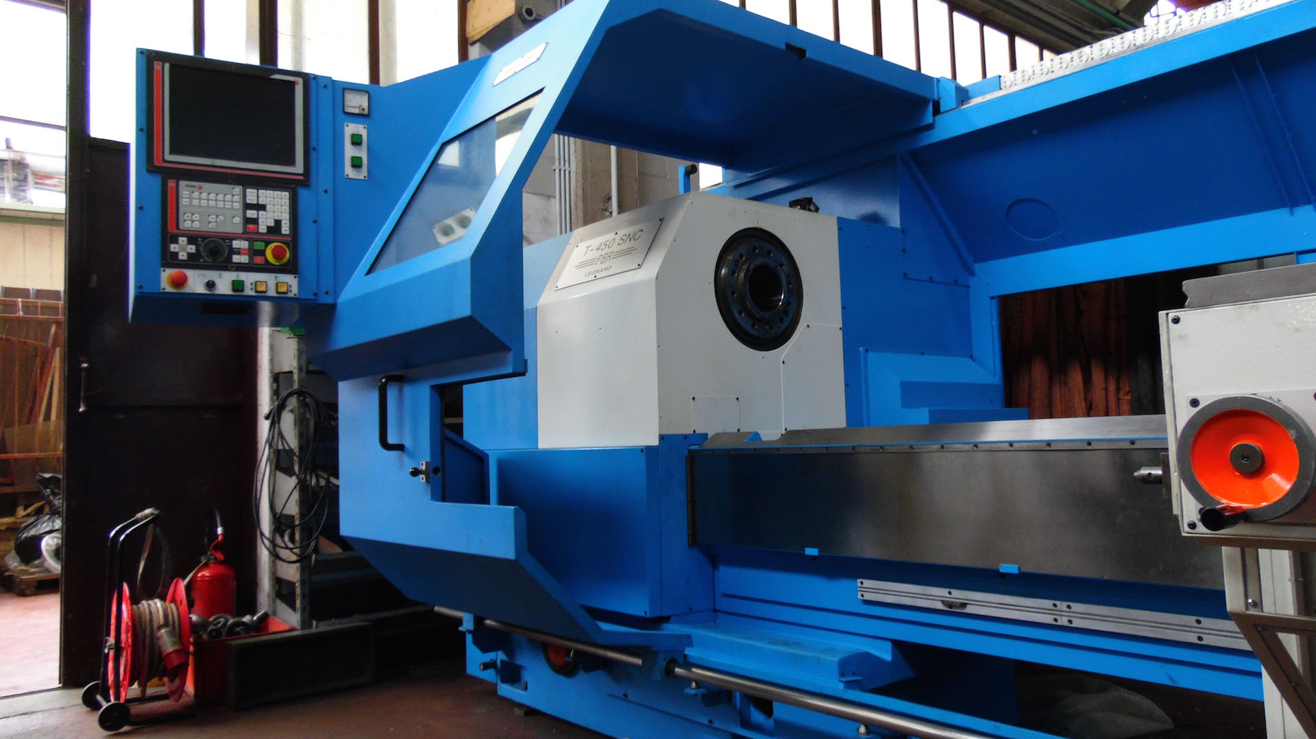

- Centre distance : 4.000
- Spindle hole : 130
- Speeds 2 ranges : 1.500 rpm.
- Feeds : 6.500 mm/min
- Rapid : 8.000 mm/min.

- Weight workpiece flying : 1.200
- Between centre : 3.500
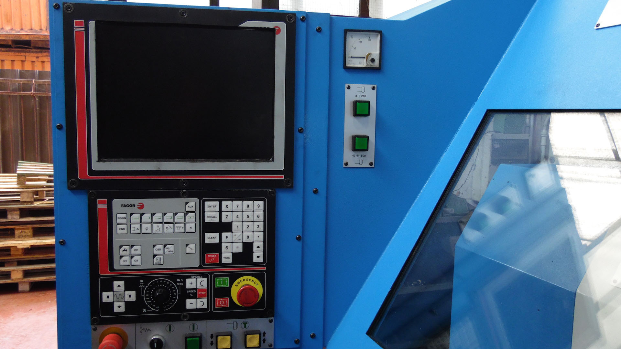
- With steady rest : 5.000

- Power : 55 kW / 400 V
- Weight : 10.400 Kg

- CNC Control FAGOR 8055
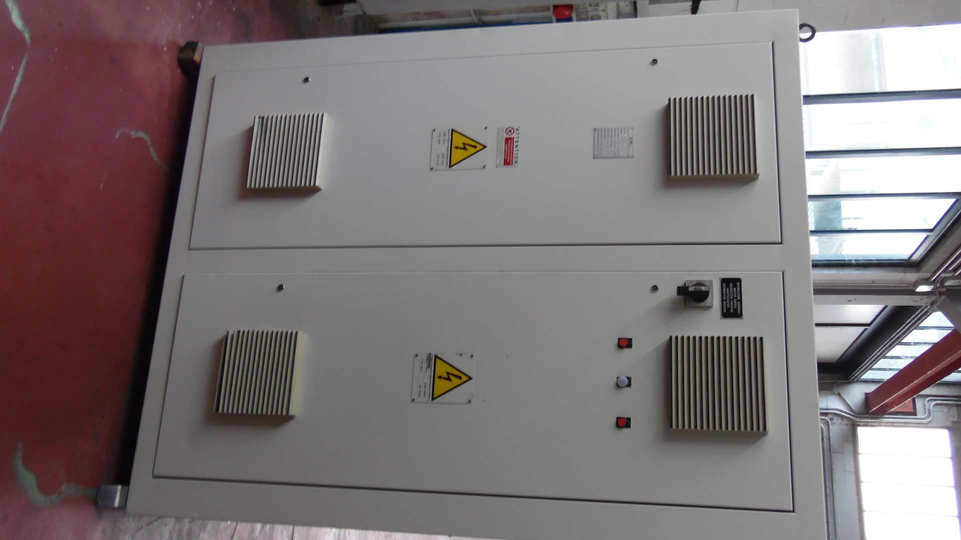
- Central lubrication
- Hardned slideways 450 Brinell
- 4 chuck Ø 800
- 3 chuck Ø 800
- Fixed steady rest Ø 500
- Boring bar Ø 150

Please Note: The above information has been obtained to the best of our ability and belief from, and from the manufacturers where possible. It is given in good faith, but its accuracy can not be guaranteed. Accordingly, it will not form a representation or constitute contractual terms. We advise you to check any vital details!

